# Assignment No: 9(c)

**TITLE:** Fractal Graphics

# PROBLEM STATEMENT:

Write C++ program to generate fractal patterns by using Koch curves.

# PREREQUISITES:

Basic knowledge of mathematic primitives

# COURSE OBJECTIVE:

1. To acquaint the learner with the basic concepts of fractal graphics
2. To get familiar with mathematics behind the graphical transformations

# COURSE OUTCOME:

Develop the competency to understand the concepts related to fractals

# THEORY:

**Fractals :** Fractals are very complex pictures generated by a computer from a single formula. They are created using iterations. This means one formula is repeated with slightly different values over and over again, taking into account the results from the previous iteration.

Fractals are used in many areas such as −

Astronomy − For analyzing galaxies, rings of Saturn, etc.

Biology/Chemistry − For depicting bacteria cultures, Chemical reactions, human anatomy, molecules, plants,

Others − For depicting clouds, coastline and borderlines, data compression, diffusion, economy, fractal art, fractal music, landscapes, special effect, etc.

# Koch curve :

The Koch curve is also known as snowflake curve. The Koch curve originally described by Helge von Koch is constructed with only one of the three sides of the original triangle. In other words, three Koch curves make a Koch snowflake.

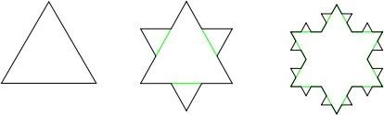

**Figure: The first three iterations of the Koch snowflake**

# ALGORITHM:

* 1. The Koch snowflake can be constructed by starting with an equilateral triangle, then recursively altering each line segment as follows:
     + Divide the line segment into three segments of equal length.
     + Draw an equilateral triangle that has the middle segment from step 1 as its base and points outward.

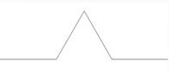

* Remove the line segment that is the base of the triangle from step 2.

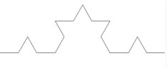

* After one iteration of this process, the resulting shape is the outline of a hexagram.

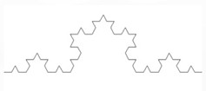

1. The Koch snowflake is the limit approached as the above steps are followed over and over again.
2. The Koch curve originally described by Koch is constructed with only one of the three sides of the original triangle.
3. In other words, three Koch curves make a Koch snowflake.

**CONCLUSION:** Fractals are studied by implementing Koch Snowflake curve.

**QUESTIONS:-**

1. Define Koch curve
2. How to construct Koch curve